**Car Control Application**

**Human-Computer Interaction**

**1st Phase: Requirement Analysis**

Filipe Pires, 85122

João Alegria, 85048

LEI – 2nd Year – 2nd Semestre 04/2018

**Overall Purpose and Goals**

The main purpose of this deliver is to present the results of a thorough requirements analysis obtained by exploring the methods of creating personas and their respective app use scenarios. The components of this paper are:

* The created Persona, reliably and realistically representing the key audience for later reference;
* The Scenarios, describing the stories and context behind why the user group (represented by the Persona) uses our application;
* The Requirements, gathered through an analysis of the Persona and the respective Scenarios, identifying the app’s key functionalities and developing limitations;
* The Prototype, the requirement analysis’ resulting draft version of the application, allowing us to explore ideas and to show the intention behind the overall design concept.

**Step 1 – User characterization through Personas**

Joaquim, a 41-year-old man living in Aveiro, is a successful economist, married to Isabel, 39, and father of 2 children, 7-year-old Filipa and 18-year-old Ricardo.

Joaquim is a very busy man, and now, with the luck of being recently promoted, he values ​​his time more than ever. Making a constant effort to always manage his time in the best way possible and to not waste time on unnecessary things, he always puts family first, spending most of his free time with them.

Given his professional area, Joaquim looks a lot at the financial side of things and tries to save where he can. The option of buying an electric car came when he realized that it would bring his family economic benefits as well as an ecological added value, all with the matter of comfort already guaranteed.

Having spent a considerable number of years driving second-hand cars and finding some problems related to this, he decided to buy a first-hand electric car. Joaquim turned out to be very pleased with his new acquisition, finding the features of his new car excellent, and some of them even innovative for his eyes. Passionate with the modern electrical world, Joaquim wondered if there would be an application that would complement his new car, making his interaction even more efficient. Access to some car features through a mobile application, such as the air conditioner and even the alarm, seems very interesting and revolutionary for a person like him.

**Step 2 – Context of Use and Routines Characterization through Scenarios**

1st Scenario:

Joaquim is 15 minutes away from finishing a long day at work. Since it is the middle of Winter and one of the coldest days of the year, he would love not to have to go through the pain of having to get to his car breathing the freezing cold air and to encounter his car even colder than he had imagined.

With that in mind, Joaquim, with the help of a smartphone app, would like to activate the air conditioning of his car without actually being inside of it, so when he arrived there he would not have to close his coat even more and would actually feel comfortable.

2nd Scenario:

To better enjoy his free time, Joaquim decided to go with his family and get to know a new city. There, they decide to go to a big shopping center that they came across. The owner of the car, his wife, and his children liked this center very much, but they encountered a problem when it was time to leave. Since they were in a unknown city and the mall’s parking location was so large, none of the members of his family remembered where they parked the car. At the time, Joaquim liked the idea of his mobile app somehow helping him locate his car.

3rd Scenario:

To ensure that his recent investment is not easily lost due to a car theft or any damage done to it, Joaquim also imagined having his mobile application warning him of any suspicious activity being carried out on his car. An option would be to receive a notification if the car’s alarm system went off.

4th Scenario:

Joaquim has not yet become accustomed to the operation of the battery of his new car. Still having difficulties in analyzing status specifications such as how many kilometers can he still drive before the battery runs out, he finds very useful to know this to be more confident before going on a trip or just leaving his office to home or somewhere else.

**Step 3 – Requirements Identification from Scenarios**

Main requirements for the Car Control Application:

* A first time user must be able to connect his car to the App in less than 5 mins;
* A user must be able to: know the car autonomy in less than 1 min;

activate the air conditioning system in less than 1 min;

make sure his car is locked in 30 secs;

evaluate the car status at any time in less than 2 mins;

* Less than 25% of the users should have difficulties in grasping the app’s main features;
* Any user must have access to online help at any time;

**Step 4 – Conceptual Validation using a Mockup (Paper Prototyping)**

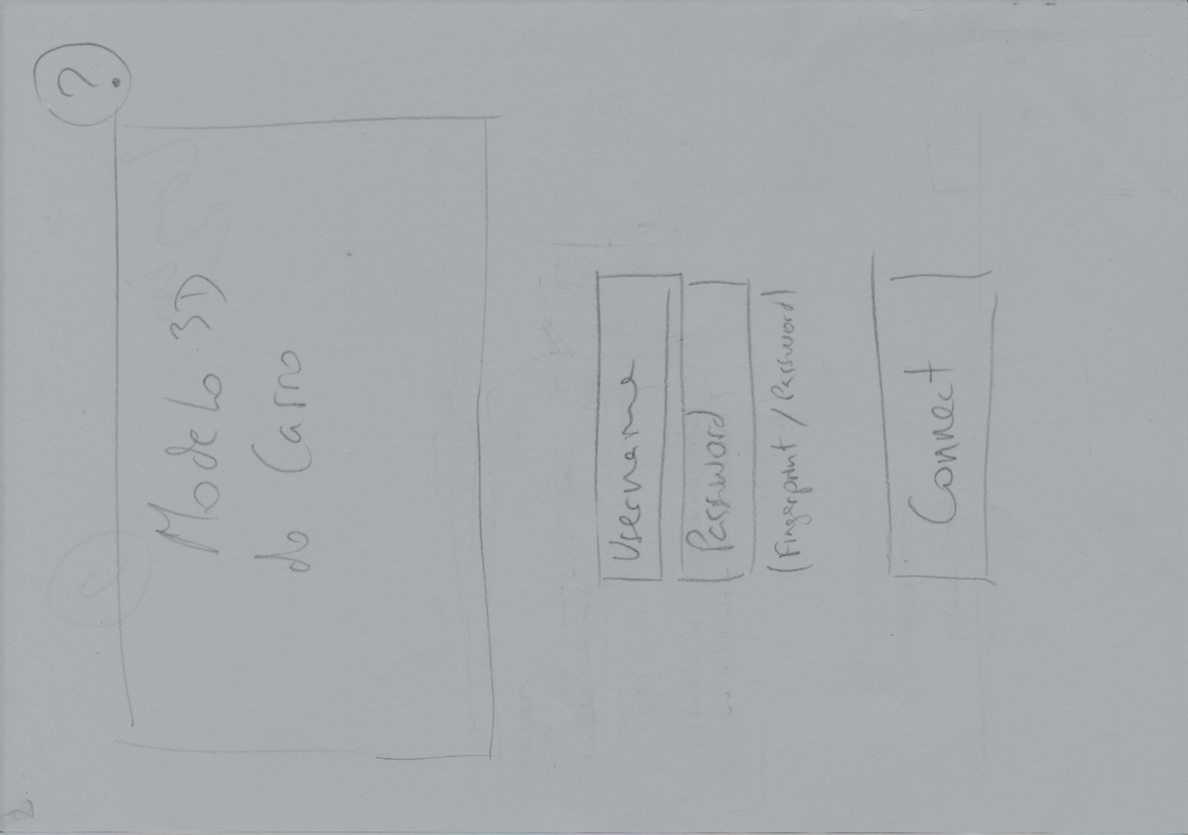

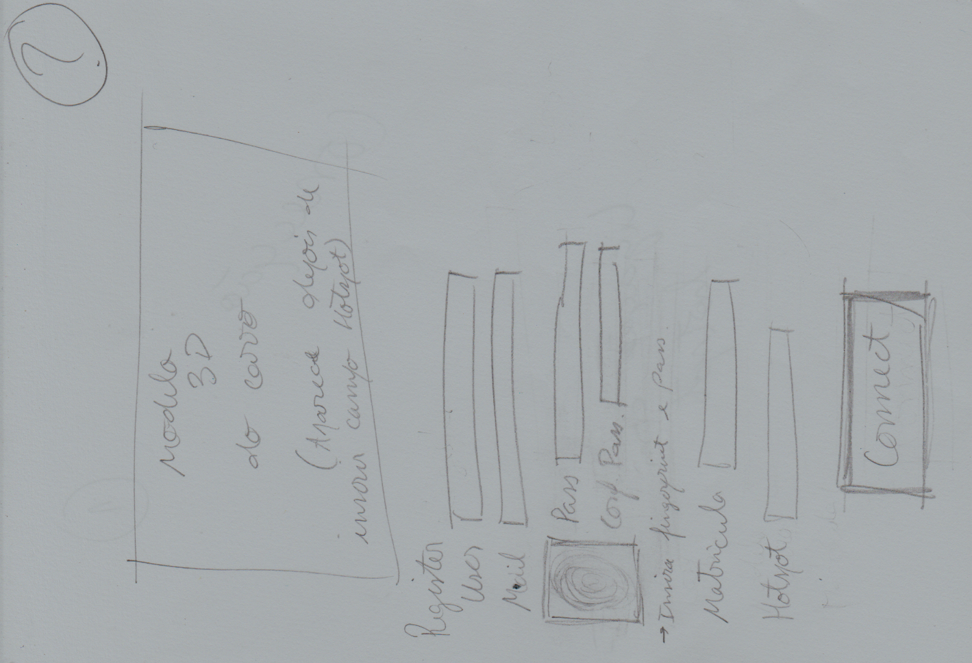

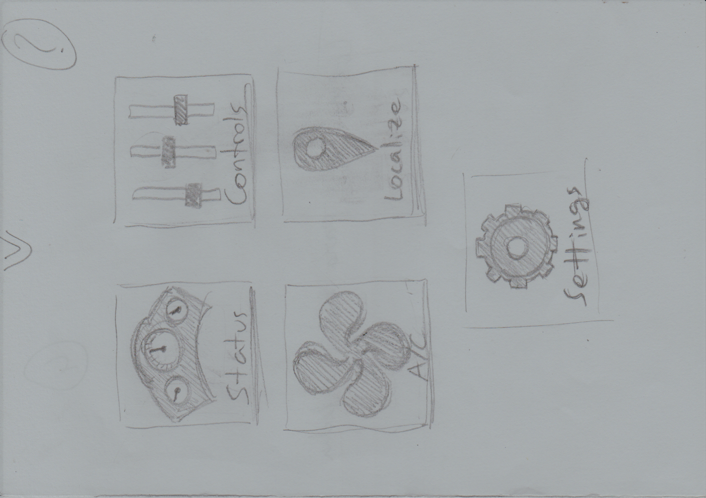

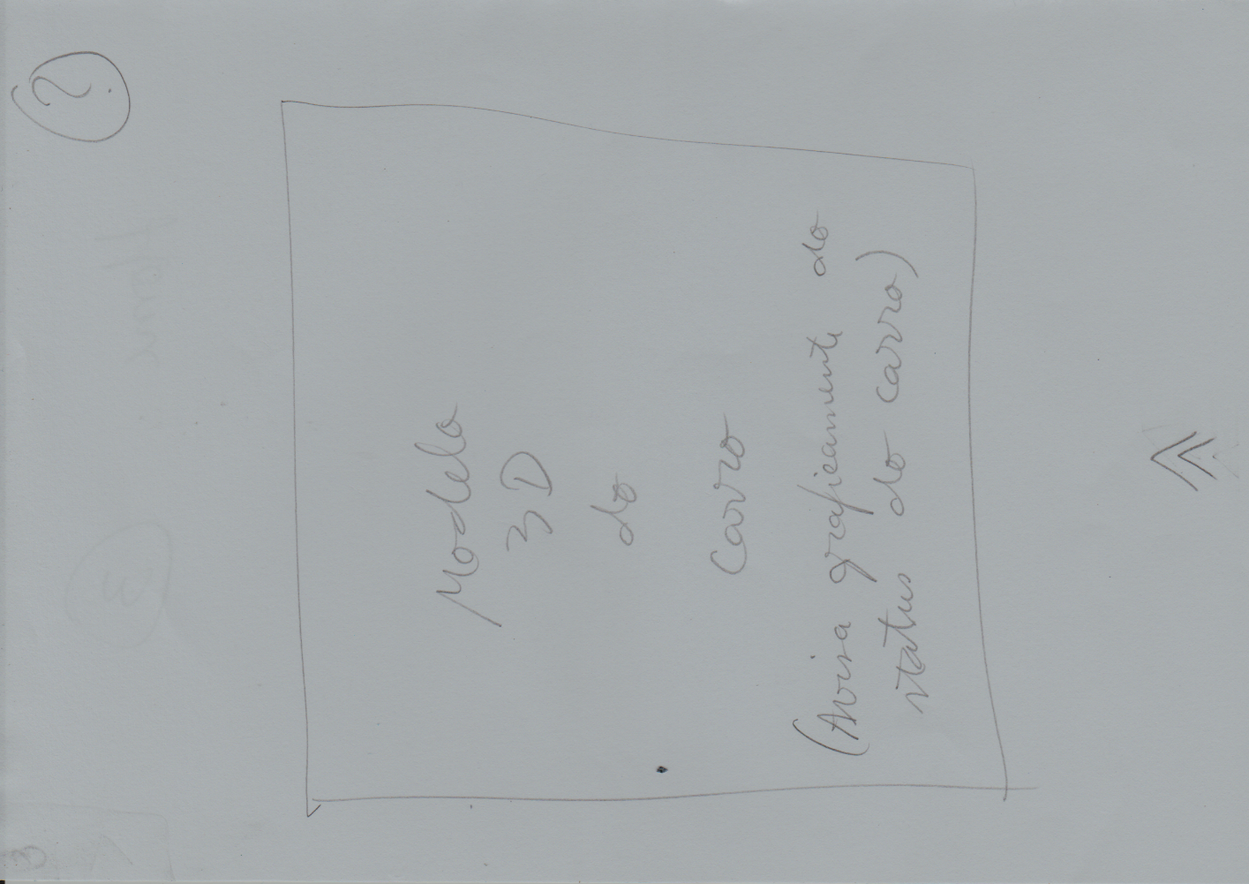

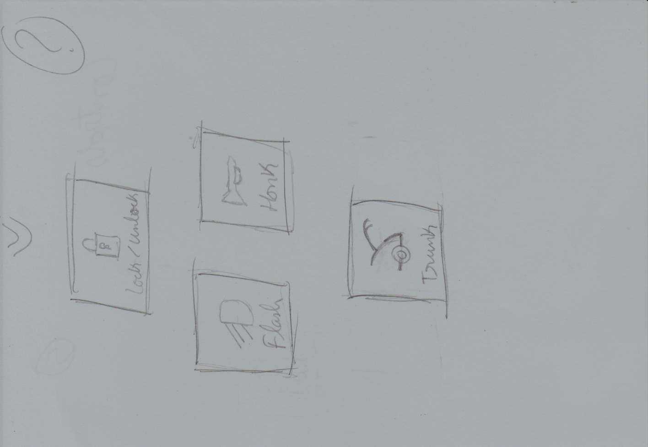

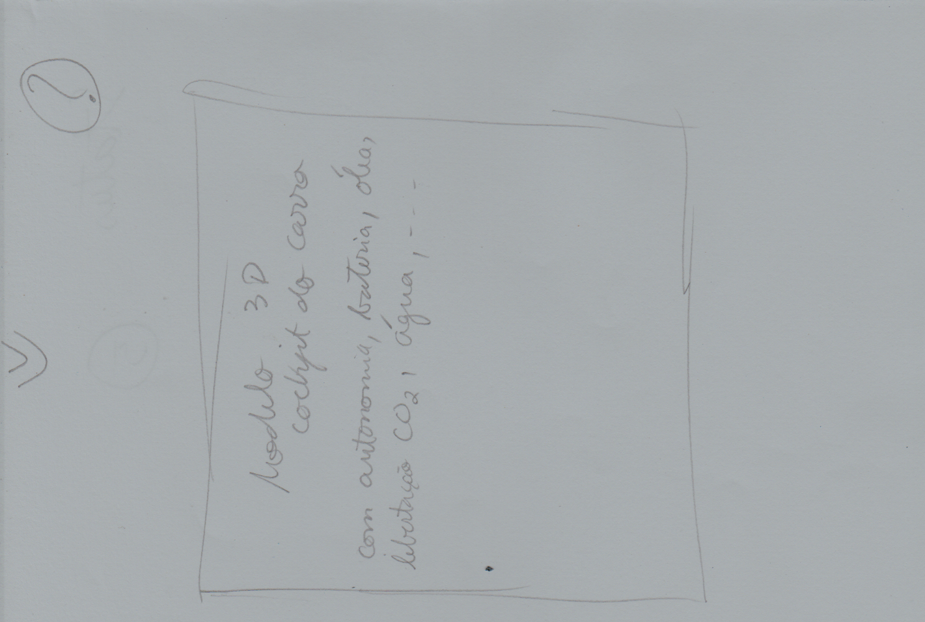





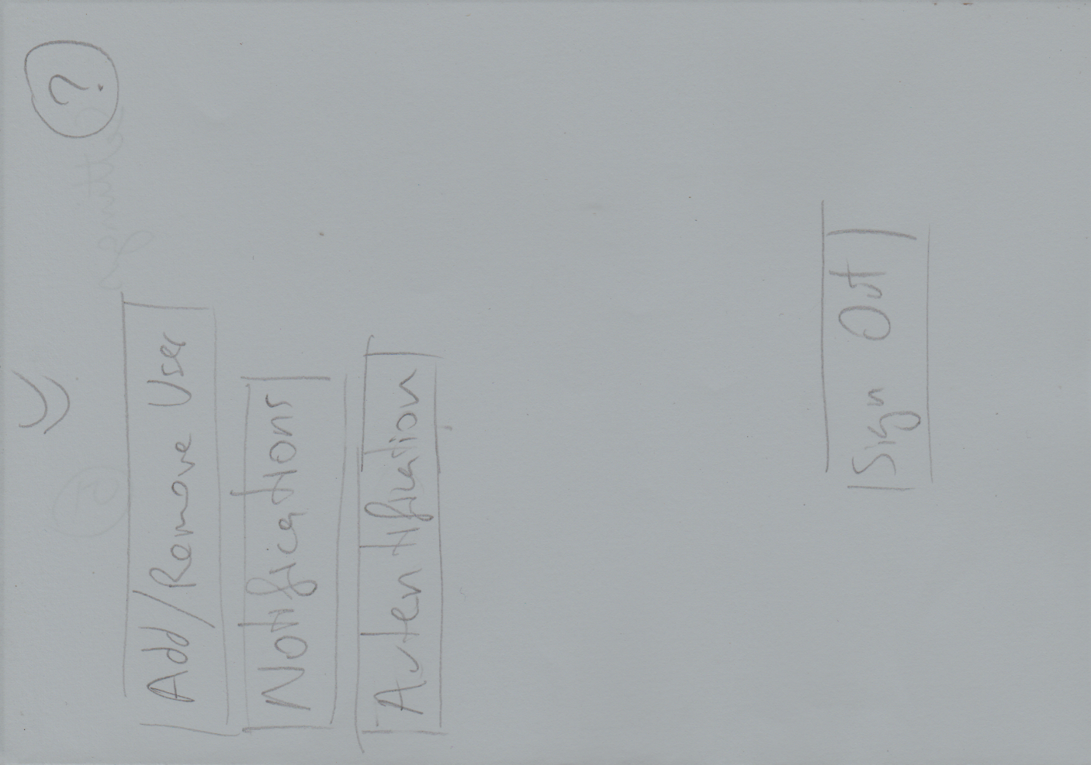

**Bibliography**

Guidelines:

<https://elearning.ua.pt/pluginfile.php/687189/mod_resource/content/1/Lab_Requirement_analysis.pdf>

Examples’ Sources:

<https://elearning.ua.pt/pluginfile.php/687228/mod_resource/content/1/RequirementElicitation_v3.pdf>

<https://elearning.ua.pt/pluginfile.php/687207/mod_resource/content/1/Task%20analysis%20example-WU.pdf>

<https://elearning.ua.pt/mod/folder/view.php?id=445146>

[https://www.youtube.com/watch?feature=player_embedded&v=ykJ60H4Qkvg#](https://www.youtube.com/watch?feature=player_embedded&v=ykJ60H4Qkvg)!

Picture:

<https://blogsk8.wordpress.com/2015/09/08/ensayo-sobre-la-importancia-del-escucha-en-un-economista/>